Task List App  
Design Document

Version 0.1 ● June 11, 2022

jwd-flex-3-project-group-3  
Team Leader – Akilah Witherspoon  
 Rob Camhi  
 Charlsey Duran  
 Summer Ranaldson  
 Paul M. Summitt

# Executive Summary

This project creates a Task Planner Web application as the final project for the Junior Web Developer Generation USA cohort. The aim of the project is to demonstrate the technical and non-technical skills developed during the program.

## Purpose of this document

The purpose of this document is to describe in sufficient detail how this Task Planner Web Application is to be constructed. The System Design Document translates the Requirement Specifications into a document from which the developers can create the actual system. It identifies the system architecture, and identifies software, communication, and interface components.

## Methodology, Tools, and Techniques

Using web technologies including HTML, CSS, JavaScript, and Bootstrap, the team will demonstrate proficiency with tools such as Figma, Git, GitHub, and Visual Studio Code to create this application.

# Software Detailed Design

Provide a detailed description of each software component.

### Opening Webpage

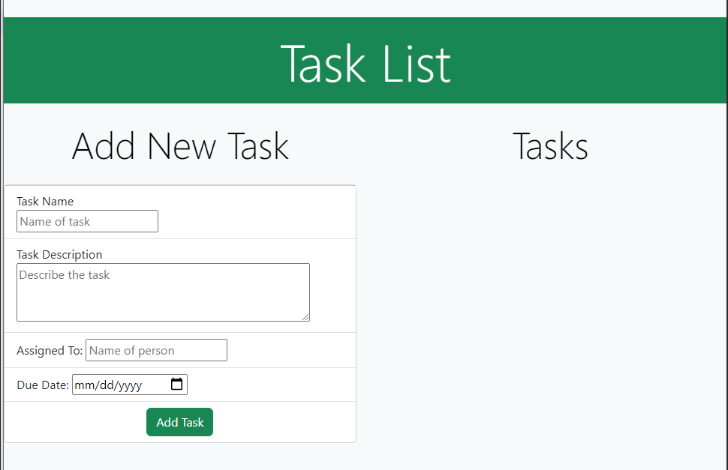

#### Attached Fonts

https://fonts.gstatic.com

https://fonts.googleapis.com

https://fonts.googleapis.com/css2?family=Roboto:wght@400;500;700&display=swap

#### Attached Stylesheets

<https://cdn.jsdelivr.net/npm/bootstrap@5.2.0-beta1/dist/css/bootstrap.min.css>

#### Attached JavaScript

https://cdn.jsdelivr.net/npm/bootstrap@5.2.0-beta1/dist/js/bootstrap.bundle.min.js

#### Banner

<dev class="col ">

<h1 class="display-1 text-center text-bg-success p-3 ">Task List</h1>

</dev>

#### Left Card

The left card is a data entry form.

Header for Left Card

<dev class="col-6 ">

<h2 class="display-4 text-center text-bg-light p-3 ">Add New Task</h2>

</dev>

Label and Input for Task Name

The user will enter the name of the task here. This entry is required. Task Name should be no more than 55 characters

<li class="list-group-item">

<label id=”lblTaskNameEntry”>Task Name<br><input id="txtTaskNameEntry" type="text" name="taskName" placeholder="Name of task" required></label>

</li>

Label and Input TaskArea for Task Description

The user enters a description of the task here. The text area is 3 rows and 50 columns in size and should contain no more than 254 characters. This entry is required.

<li class="list-group-item">

<label>Task Description<br><textarea id="txttaskDescription" rows=3 cols=50 name="taskDescription" placeholder="Describe the task" required></textarea></label>

</li>

Label and Input for Assigned To

The person assigned the listed task is entered here. The entry is required.

<li class="list-group-item">

<label>Assigned To: <input type="text" name="assignedTo" placeholder="Name of person" required></label>

</li>

Label and Input for Date Due

The use must choose the date that the task is due. This entry is required. The current date is always shown in the input area. Date is always listed as YYYY-MM-DD.

<li class="list-group-item">

<label>Due Date: <input type="date" id="dateDue" name="date-due" min="2022-01-01" max="2023-12-31" required></label>

</li>

Add Task Button

The user clicks the Add Task button to submit the entered data to the application. If any data is missing the user will be given a message stating what is missing. Clicking the button also makes the card on the right visible as seen in the second Web page below.

<li class="list-group-item d-flex justify-content-center">

<button class="btn btn-success font " id="btnAddTask" type="submit" value="Submit" onclick="changeCard();">Add Task</button>

</li>

### Second Web page

#### Right Card

The right card is a data display form. The form is invisible until the user enters all required information on the data entry form and clicks the Add Task button. The form then becomes visible with the necessary date displayed appropriately.

Labels for Task Name and Task Name display

The data entered under Task Name on the Left Card will be displayed here.

<li class="list-group-item ">

<label>Task Name:<label id="lblTaskName " type="text " name="lblTaskName "></label>

</li>

Labels for Task Description and Task Description display

The data entered under Task Description on the Left Card will be displayed here.

<li class="list-group-item ">

<label>Task Description:<label id="lblTaskDescription " type="text" name="lblTaskDescription "></label>

</li>

Labels for Assigned To and Assigned To display

The data entered under Assigned To on the Left Card will be displayed here.

<li class="list-group-item ">

<label>Assigned To:<label id="lblAssignedTo " type="text " name="lblAssignedTo "></label>

</li>

Labels for Due Date and Due Date display

The data entered under Due Date on the Left Card will be displayed here.

<li class="list-group-item ">

<label>Due Date:<label id="lblDateDue " type="date " name="lblDateDue "></label>

</li>

Mark As Done Button

The user may use this button to mark the associated task as completed. Use of this button will change the Status display from “In Progress” to “Completed.”

<div class="col ">

<button class="btn btn-warning " id="btnMarkAsDone " type="submit " value="Done ">Mark As Done</button>

</div>

Delete Button

The user may use this button to delete the associated task from the application. The data is deleted and unrecoverable.

<div class="col ">

<button class="btn btn-danger " id="btnDelete " type="submit " value="Delete ">Delete</button>

</div>

Labels for Status and Status Display

The status of the Task will be displayed here. Initially the status will be displayed as “In Progress.”

<li class="list-group-item ">

<label class="display-5 "><strong>Status:</strong><label id=" lblStatus " type="text " name="lblStatus "></label>

</li>